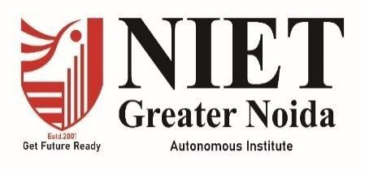

INTERNSHIP REPORT
A Report Submitted In Partial Fulfillment
for award of Bachelor of Technology

In
INFORMATION TECHNOLOGY

By
SPARSH KUMAR 2301330130183

Under the Supervision of
Institutional Supervisor

MS. SHALINI SHROTRIYA

INFORMATION TECHNOLOGY
School Name

NOIDA INSTITUTE OF ENGINEERING AND TECHNOLOGY, GREATER NOIDA
(An Autonomous Institute) Affiliated to
DR. A.P.J. ABDUL KALAM TECHNICAL UNIVERSITY, LUCKNOW
NOVEMBER-2025

DECLARATION

We hereby declare that the report work presented in this report entitled “INTERNSHIP IN JAVA DEVELOPMENT”, in partial fulfilment of the requirement for the award of the degree of Bachelor of Technology, submitted to Department of Information Technology NIET, Greater Noida. The work contained in the report is true and original to the best of our knowledge and internship work reported in this report has not been submitted by us for award of any other degree or diploma.

Name : Sparsh Kumar Roll Number : 2301330130183

(Student Signature)

CERTIFICATE

This is to certify that the Project report entitled with “Internship in Java Development” done by Sparsh Kumar (2301330130183) is an original work carried out by them in Department of Information Technology, NIET, Greater Noida under my guidance. The matter embodied in this project work has not been submitted earlier for the award of any degree or diploma to the best of my knowledge.

Signature

Ms. Shalini Shrotriya Information Technology NIET Greater Noida

Date:
Signature

Dr. Ritesh Rastogi Information Technology NIET Greater Noida

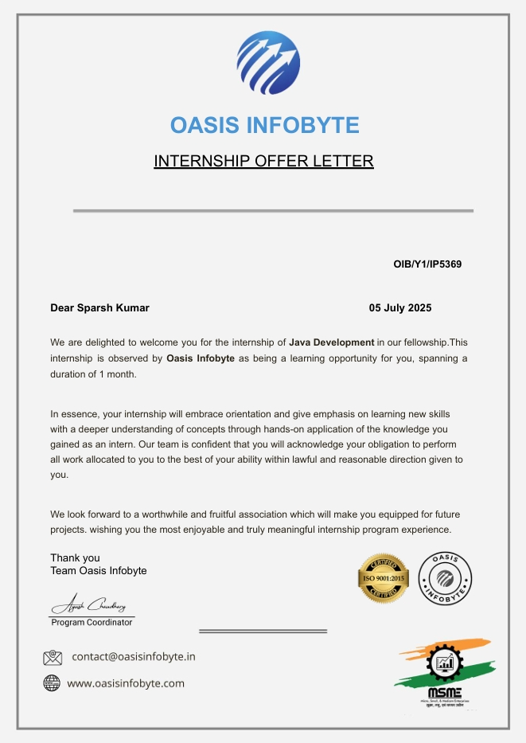

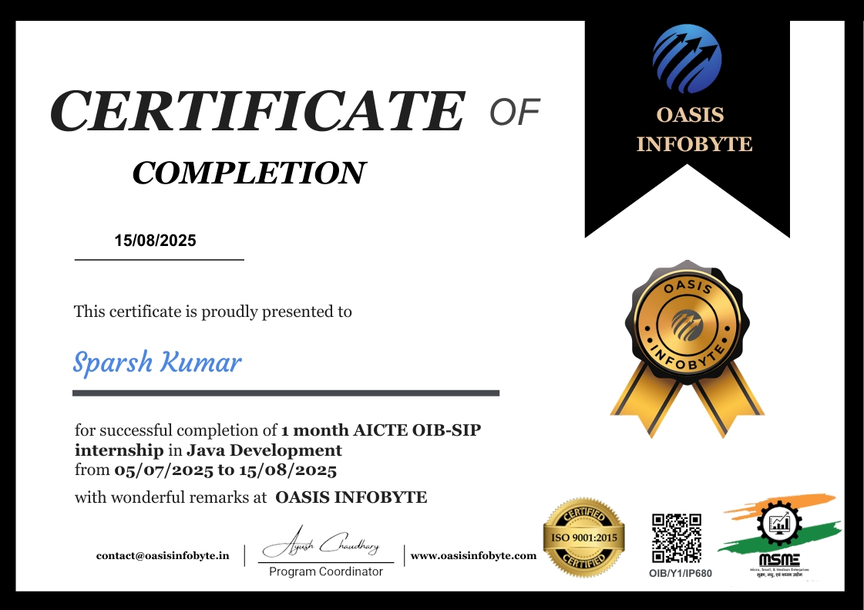

ACKNOWLEDGEMENT

I would like to express my gratitude towards Ms. Shalini Shrotriya for their guidance, support and constant supervision as well as for providing necessary information during my internship. My thanks and appreciations to respected HOD Dr. Ritesh Rastogi, for their motivation and support throughout.

ABSTRACT

This report presents the details of the Java Development internship undertaken at Oasis Infobyte. The internship involved working on JAVA projects such as Handwritten Digit Recognition and Spam Email Classification using Machine Learning algorithms. The internship provided hands-on exposure to tools like Python, NumPy, Pandas, Scikit-learn, and Jupyter Notebook, enhancing both theoretical knowledge and practical implementation skills in AI and ML.

TABLE OF CONTENTS

Page No.
Declaration i
Certificate from the institute ii
Offer Letter from industry iii
Certificate from the industry iv
Acknowledgement v
Abstract vi
CHAPTER 1: INTRODUCTION 1-8
  - ORGANIZATION OVERVIEW 1
    - Company History and Background 1
    - Services and Products 3-5
  - OBJECTIVE AND SCOPE 6-8
    - Objective 6
    - Scope 7
CHAPTER 2: INTERNSHIP EXPERIENCE 9-28
2.1 Project worked on 9
2.2 Tools and Technology used 17
2.3 Roles and responsibilities of the intern 18
2.4 Details of work done 18
2.5 Skills Learnt 20
CHAPTER 3: CONCLUSION AND FUTURE WORK 23-24
REFERENCES 25

CHAPTER 1

INTRODUCTION

  - ORGANIZATION OVERVIEW
    - Company History and Background
Infosys Wingspan is a modern digital learning and skill development platform created by Infosys to support learners, freshers, and employees in developing industry-relevant technical competencies. It was built with the vision of promoting continuous learning, technology upskilling, and self-paced education aligned with global IT standards.
The platform leverages Infosys’ decades-long expertise in IT services, software engineering, and enterprise-level solutions. Wingspan aims to make learning accessible, interactive, and job-oriented for students and professionals worldwide.
Growth and Development of Infosys Wingspan
Over the years, Wingspan has expanded into a highly comprehensive online learning ecosystem:
- 2018–2019: Introduction of foundational IT courses (DBMS, Programming, Cloud Basics).
- 2020: Addition of hands-on labs, coding playgrounds, and AI-driven assessments.
- 2021–2022: Integration of advanced technologies such as cybersecurity training, cloud certification modules, and real-world project simulations.
- 2023–2024: Enhanced industry collaboration, updated curriculum aligned with modern IT trends, and expansion to include more specialized domains.
Infosys Wingspan has now become a widely recognized digital learning environment used by students, institutions, and corporate trainees across the world.
Key Achievements
- Awarded as a Leading Digital Learning Platform for enterprise upskilling programs.
- Provides globally recognized courses including DBMS, SQL, AI, Cloud Computing, and Software Engineering.
- Successfully trained thousands of learners through self-paced, assessment-based modules.
- Offers real-time simulations and coding environments, making learning interactive and practical.
Innovation & Platform Features
Infosys Wingspan includes:
- Interactive video lessons
- Live coding playgrounds for SQL and programming
- Instant feedback on assessments
- Hands-on database environments
- Industry-standard case studies
This continuous innovation ensures learners receive modern, industry-ready education aligned with the needs of the IT sector.

    - Services and Offerings

Infosys Wingspan provides a wide range of learning and training services, including:
1. Technical Courses
- Database Management Systems (DBMS)
- Structured Query Language (SQL)
- Cloud Computing
- Data Structures
- Python & Java Programming
- Web Development Basics
2. Hands-on Practice Environments
- SQL Playground
- Database Simulator
- Virtual labs and assignments
- Real-time debugging environment
3. Skill Development Modules
- Logical reasoning
- Problem-solving
- Analytical thinking
- Communication and professional skill enhancement
4. Industry-Ready Certifications
Upon completion, learners receive Infosys-recognized certificates that strengthen employability in the IT field.

  - OBJECTIVE AND SCOPE

Objective
The main objective of the Database and SQL internship equivalent module was to help learners gain strong foundational and practical skills in database management and SQL programming. The specific objectives include:
- To understand DBMS concepts, relational models, and ER diagrams.
- To gain proficiency in SQL syntax, commands, and real-world query writing.
- To learn and practice DDL (CREATE, ALTER, DROP) operations.
- To implement DML (INSERT, UPDATE, DELETE) operations.
- To execute complex SQL tasks using WHERE, ORDER BY, GROUP BY, HAVING.
- To work with Joins, subqueries, and multi-table operations.
- To develop hands-on expertise using the Wingspan SQL Playground.
- To strengthen logical thinking and problem-solving through query-based assignments.
The objective was to ensure students become industry-ready in database handling, query writing, and relational data analysis.

Scope
The scope of this internship covers both the conceptual and practical dimensions of SQL and database management:
1. Technical Learning Scope
- Understanding DBMS architecture
- Learning relational models and constraints
- Creating and managing tables
- Querying structured data
- Performing sorting, filtering, and grouping operations
- Working with joins & subqueries
- Implementing real SQL tasks in the simulator
- Improving query optimization and efficiency
2. Tools and Technologies Covered
- SQL (Structured Query Language)
- DBMS concepts
- RDBMS principles
- Infosys SQL Playground
- Database Simulator
- Wingspan Learning Platform
3. Professional Skill Development
- Problem solving using database queries
- Logical reasoning and data interpretation
- Self-paced learning discipline
- Time management during hands-on assignments
- Understanding industry-standard documentation practices
4. Practical Exposure
- Performing end-to-end SQL operations
- Creating database schemas
- Executing large datasets using SQL tools
- Real-time debugging and correction
5. Future Learning Scope
This program lays the foundation for advanced subjects such as:
- Stored Procedures & Functions
- Triggers
- Indexing
- Query Optimization
- Data Warehousing
- Big Data and NoSQL

CHAPTER 2

INTERNSHIP EXPERIENCE

This chapter provides an overview of my experience during the Database and SQL internship module offered through Infosys Wingspan. It highlights the activities I worked on, the SQL techniques I practiced, the tools I used, and the competencies I developed. This internship allowed me to understand the real-world implementation of relational databases, SQL queries, data structuring, and data retrieval techniques used in industry-level applications.

2.1 PROJECTS WORKED ON
Throughout the internship, I worked on a structured learning project titled:
Database and SQL Learning Project
The project was designed to gradually develop my skills in:
- Database creation
- Table structuring
- Data retrieval
- Data filtering and sorting
- Group-based analysis
- Multi-table operations using joins
- Nested querying for complex tasks
Each topic included conceptual explanations, hands-on assignments, and real-time practice using the Wingspan SQL playground.
Below is the detailed breakdown of the tasks and mini-projects completed:

1. DBMS Fundamentals and ER Diagrams
The first module focused on the foundational concepts of:
- What is a DBMS
- Advantages of DBMS over file systems
- Entities, attributes, and relationships
- ER diagrams and cardinality
- Concept of keys (Primary, Foreign, Candidate)
Practical Tasks Included:
- Creating basic ER diagrams
- Identifying entity relationships for sample scenarios
- Mapping ER diagrams to relational schema

2. SQL Basics
This module introduced the core structure and syntax of SQL commands.
Tasks Completed:
- Using SELECT to retrieve data
- Applying operators
- Understanding DISTINCT, AS, and aliasing
- Implementing filters using WHERE
Learning Outcome:
How SQL interacts with relational databases to extract meaningful information.

3. DDL (Data Definition Language) Operations
This module helped me understand how to design and define database structures.
DDL Commands Practiced:
- CREATE TABLE – defining schema
- ALTER TABLE – adding/removing/modifying columns
- DROP TABLE – deleting tables
- Applying constraints such as:
  - PRIMARY KEY
  - NOT NULL
  - UNIQUE
  - FOREIGN KEY
  - CHECK
Mini-Project:
Created tables for a student-course database, including constraints and relational links.

4. DML (Data Manipulation Language) Operations
After designing the tables, I worked on data manipulation.

DML Work Included:
- Inserting multiple records using INSERT
- Updating values using UPDATE
- Deleting records using DELETE
- Handling NULL values
Mini-Project:
Populated an employee database and performed multiple updates and deletions based on requirements.

5. Sorting & Filtering Data
Commands Practiced:
- ORDER BY ascending and descending
- Conditional retrieval using WHERE operators such as:
  - >, <, BETWEEN, LIKE, IN, NOT IN
Case Exercises:
- Filtering high-scoring students
- Sorting products based on price
- Extracting employees above a certain salary range

6. GROUP BY and Aggregate Functions
Using SQL aggregate functions, I performed:
- COUNT()
- SUM()
- AVG()
- MIN()
- MAX()
Tasks Completed:
- Grouping customers by city
- Calculating total sales per category
- Finding average marks per subject
- Using HAVING for conditional grouping

7. JOINS (Single and Multi-Table Queries)
This was one of the most important modules.

Joins Practiced:
- INNER JOIN
- LEFT JOIN
- RIGHT JOIN
- FULL JOIN (conceptually)
- SELF JOIN
Mini-Project:
Linked students, courses, and enrollments tables to retrieve:
- Course-wise enrollment
- Student performance across subjects
- Instructor-course mappings
This module strengthened my understanding of relational databases and multi-table query handling.

8. Subqueries and Nested SQL
I learned how to write inner queries to solve complex retrieval tasks.
Subqueries Used For:
- Fetching records based on aggregated results
- Extracting top-performing employees
- Identifying unregistered students
- Filtering data using correlated subqueries
Example Tasks:
- Finding product with the maximum price using subquery
- Retrieving employees earning above average salary

Overall Project Outcome
By the end of this project, I was able to:
- Design and structure databases
- Perform end-to-end SQL operations
- Solve real-world data problems
- Write efficient, readable SQL queries
- Understand the logic behind relational data handling

2.2 TOOLS AND TECHNOLOGIES USED
During this internship, I used the following tools and technologies:
Technical Tools
- SQL (Structured Query Language)
- Infosys Wingspan SQL Playground
- DBMS/RDBMS Concepts
- Database Simulator Environment
Software Tools
- Infosys Wingspan Platform
- Online DB editors (in-built)
Concepts & Techniques
- Relational data structures
- Constraints & normalization basics
- Query optimization basics
These tools allowed me to apply concepts instantly and evaluate the output in real time.

2.3 ROLES AND RESPONSIBILITIES
During the internship, my responsibilities included:
- Understanding DBMS concepts and relational models
- Creating and modifying database tables
- Writing SQL queries for data insertion and deletion
- Performing filtering, sorting, and grouping operations
- Applying joins across multiple tables
- Solving weekly SQL assignments
- Completing hands-on tasks in the SQL Playground
- Reviewing, debugging, and optimizing queries
- Taking assessments to validate learning progress

2.4 DETAILS OF WORK DONE
During the course of the internship, I performed:
1. Database Schema Design
- Designed tables using DDL
- Applied constraints
- Created relationships
2. Data Preparation
- Inserted sample datasets
- Cleaned unwanted values
- Practiced structured data management
3. Query Writing
- Retrieved targeted information
- Used complex conditions
- Sorted and filtered data
4. Aggregation & Analysis
- Applied grouping and aggregation
- Performed numeric analyses
5. Multi-Table Operations
- Joined tables
- Built relational queries
- Retrieved merged datasets
6. Subquery Implementation
- Wrote nested queries
- Solved complex retrieval problems
7. Assessments & Projects
- Completed practical tasks
- Scored high in module assessments
- Documented the learning process

2.5 SKILLS LEARNED
Technical Skills
- SQL Query Writing
- Database Schema Design
- Data Manipulation (DML)
- Table Creation & Modification (DDL)
- Use of Joins & Subqueries
- Relational Data Analysis
- Understanding of ER Diagrams
- Query Debugging & Optimization Basics
Analytical Skills
- Logical thinking
- Data interpretation
- Structured problem-solving
Professional Skills
- Self-paced learning discipline
- Time management
- Database documentation
- Accuracy in query writing
- Understanding industry workflows

CHAPTER 3

CONCLUSION AND FUTURE WORK

Conclusion

The JAVA DEVELOPMENT internship at Oasis Infobyte provided a significant opportunity to apply theoretical knowledge to real-time practical scenarios. Throughout the internship period, I worked on two major projects — Handwritten Digit Recognizer and Spam Email Classifier — which helped me gain an in-depth understanding of how AI and Machine Learning models are designed, trained, and deployed.
The Handwritten Digit Recognizer project enabled me to explore image classification using Convolutional Neural Networks (CNNs), learning how deep learning models extract complex patterns and features from raw image data. The Spam Email Classifier, on the other hand, introduced me to Natural Language Processing (NLP) and text classification, giving me practical exposure to tokenization, TF-IDF vectorization, and supervised learning algorithms like Naïve Bayes and Logistic Regression.
Both projects enhanced my knowledge of data preprocessing, feature extraction, model training, and evaluation metrics such as accuracy, precision, recall, and F1-score. Additionally, working with tools such as Python, Jupyter Notebook, TensorFlow, Keras, and Scikit-learn strengthened my technical skills and programming efficiency.
The internship also helped me develop several non-technical competencies, including teamwork, communication, adaptability, and analytical problem-solving. Regular mentor feedback sessions improved my ability to handle challenges effectively and approach problems with a research-oriented mindset.
In summary, this internship acted as a bridge between academic learning and industrial practice. It helped me gain confidence in working on real-world AI problems, understand professional work ethics, and become more efficient at writing clean, structured, and well-documented code.

Future Work

While the internship successfully met its objectives, there are several potential areas for future enhancement and research:
    - Model Optimization and Deployment: The models can be further optimized using advanced architectures like Recurrent Neural Networks (RNNs) or Transformer-based models (BERT) for text classification and CNN improvements (ResNet, EfficientNet) for image recognition. The trained models can also be deployed using Flask or FastAPI to create interactive web or mobile applications.
    - Larger and More Diverse Datasets: Incorporating larger datasets with more complex and varied examples can help improve the robustness and generalization capability of the models.
    - Real-time Implementation: Future work can include integrating the spam classifier into real- time email systems for automatic filtering or using the digit recognizer in financial and educational institutions where handwritten data processing is frequent.
    - Explainable AI (XAI): Introducing explainability into the models can make them more interpretable, allowing users to understand why a particular decision (spam or ham, digit classification, etc.) was made.
    - Integration with Cloud and APIs: The AI models can be hosted on cloud platforms such as AWS, Azure, or Google Cloud for scalable deployment, and connected with APIs for easier integration into existing systems.
    - Collaboration and Research Expansion: Future collaborations with mentors and industry professionals can help refine the models and explore new research directions in ethical AI, bias reduction, and model transparency.
To conclude, the internship at Oasis Infobyte was an invaluable learning experience that strengthened both my technical and professional skills. It provided a solid foundation in JAVA DEVELOPMENT, Machine Learning, and Deep Learning, preparing me for future academic research and professional roles in AI-driven industries. The practical exposure gained from this internship has motivated me to pursue continuous learning and contribute to the field of JAVA DEVELOPMENT through innovation and research.

REFERENCES

- I. Goodfellow, Y. Bengio, and A. Courville, Deep Learning. Cambridge, MA: MIT Press, 2016.[Chapter 2: Handwritten Digit Recognizer (CNN)]
- A. Géron, Hands-On Machine Learning with Scikit-Learn, Keras, and TensorFlow, 2nd ed. Sebastopol, CA: O’Reilly Media, 2019.[Chapter 2: Model Development]
- S. Raschka and V. Mirjalili, Python Machine Learning, 3rd ed. Birmingham, U.K.: Packt Publishing, 2020.[Chapter 2: Spam Email Classifier (SVM, Naïve Bayes)]
- D. Jurafsky and J. H. Martin, Speech and Language Processing, 3rd ed. Upper Saddle River, NJ: Pearson Education, 2021.[Chapter 2: Spam Email Classifier (NLP)]
- Y. LeCun, L. Bottou, Y. Bengio, and P. Haffner, “Gradient-based learning applied to document recognition,” Proc. IEEE, vol. 86, no. 11, pp. 2278–2324, Nov. 1998.{Chapter 2: Handwritten Digit Recognizer (LeNet and MNSIT)]
- Scikit-learn Documentation, Scikit-learn Developers, [Online]. Available: https://scikit- learn.org/stable/[Chapter 2: Code for Both Projects]
- TensorFlow Documentation, Google Developers, [Online]. Available: https://www.tensorflow.org/ [Chapter 2: CNN Implementation]
- Keras API Reference, Keras Team, [Online]. Available: https://keras.io/api/ [Chapter 2: CNN Model Training]
- Pandas Documentation, Pandas Team, [Online]. Available: https://pandas.pydata.org/docs/ [Chapter 2: Data Preprocessing in Spam Email Classifier]
- NumPy Documentation, NumPy Developers, [Online]. Available: https://numpy.org/doc/ [Chapter 2: Data Normalization]
- Kaggle Datasets, Kaggle Inc., [Online]. Available: https://www.kaggle.com/ [Chapter 2: Kaggle Datasets]
- Oasis Infobyte Internal Training Material, Oasis Infobyte Pvt. Ltd., 2025.[Chapter 1: Organization Overview and Chapter 2: Internship Experience]

